Day 3 test questions:

1. Count the Number of Vowels and Consonants in a Sentence

Program:

#include <stdio.h>

#include <string.h>

#include <ctype.h>

void countVowelsAndConsonants(const char \*str, int \*vowels, int \*consonants) {

\*vowels = 0;

\*consonants = 0;

for (int i = 0; str[i] != '\0'; i++) {

char ch = tolower(str[i]);

if (isalpha(ch)) {

if (ch == 'a' || ch == 'e' || ch == 'i' || ch == 'o' || ch == 'u') {

(\*vowels)++;

} else {

(\*consonants)++;

}

}

}

}

int main() {

char str[100];

int vowels, consonants;

printf("Enter a string: ");

fgets(str, sizeof(str), stdin);

str[strcspn(str, "\n")] = '\0';

countVowelsAndConsonants(str, &vowels, &consonants);

printf("Number of vowels: %d\n", vowels);

printf("Number of consonants: %d\n", consonants);

return 0;

}

Output:

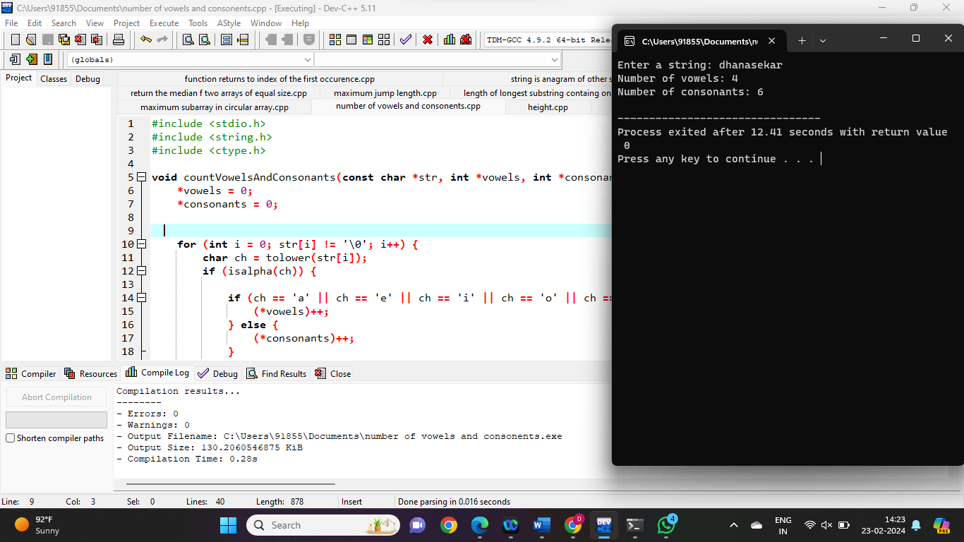

1. Accept the Height of a Person & Categorize as Taller, Dwarf & Average

Program:

#include <stdio.h>

int main()

{

float height;

printf("Enter the Height (in centimetres) \n");

scanf("%f", &height);

if (height < 150.0)

printf("Dwarf \n");

else if ((height >= 150.0) && (height <= 165.0))

printf(" Average Height \n");

else if ((height > 165.0) && (height <= 195.0))

printf("Taller \n");

else

printf("Abnormal height \n");

}

Output:

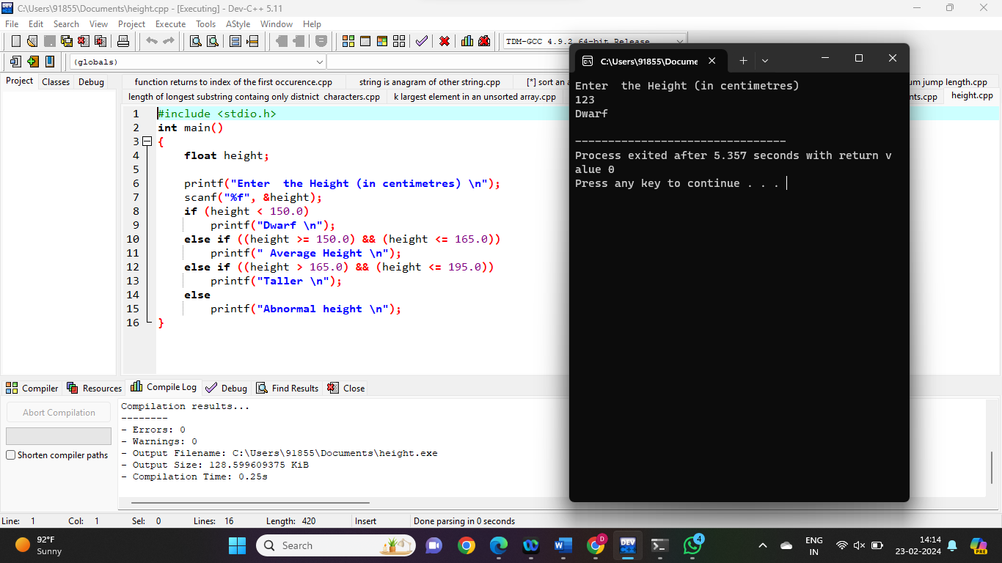

1. Prime Number or not

Program:

#include <stdio.h>

int main() {

int n, i, flag = 0;

printf("Enter a positive integer: ");

scanf("%d", &n);

if (n == 0 || n == 1)

flag = 1;

for (i = 2; i <= n / 2; ++i) {

if (n % i == 0) {

flag = 1;

break;

}

}

if (flag == 0)

printf("%d is a prime number.", n);

else

printf("%d is not a prime number.", n);

return 0;

}

Output:

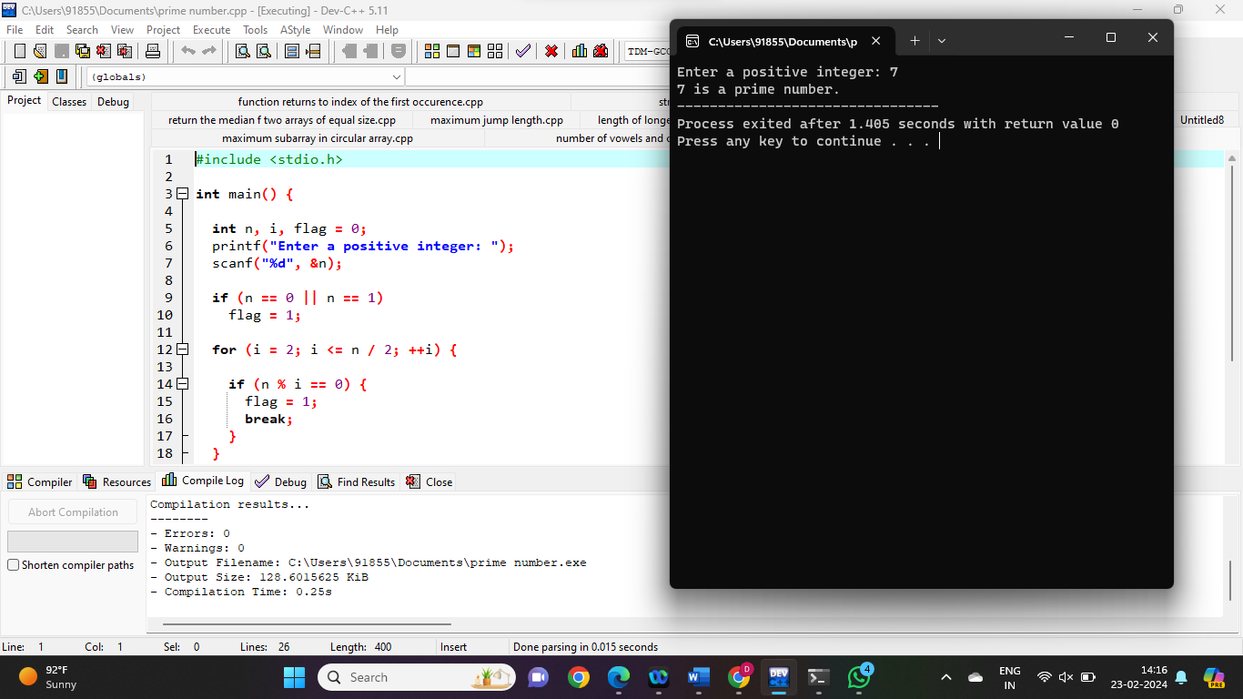

1. Check Whether a Given Number is Perfect Number

Program:

#include <stdio.h>

int main()

{

int number, rem, sum = 0, i;

printf("Enter a Number: ");

scanf("%d", &number);

for (i = 1; i <= (number - 1); i++)

{

rem = number % i;

if (rem == 0)

{

sum = sum + i;

}

}

if (sum == number)

printf("%d is perfect number", number);

else

printf("%d is not a perfect number", number);

return 0;

}

Output:

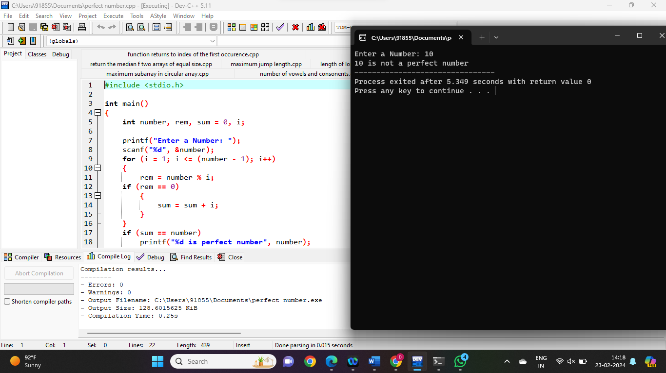

1. Check Armstrong Number

Program:

#include <stdio.h>

int main() {

int num, originalNum, remainder, result = 0;

printf("Enter a three-digit integer: ");

scanf("%d", &num);

originalNum = num;

while (originalNum != 0) {

remainder = originalNum % 10;

result += remainder \* remainder \* remainder;

originalNum /= 10;

}

if (result == num)

printf("%d is an Armstrong number.", num);

else

printf("%d is not an Armstrong number.", num);

return 0;

}

Output:

